SETTING UP APPLICATION ENVIRONMENT

Install IBM Cloud CLI:

Over here after created account in the IBM cloud there are some tutorials in the dashboard. Over there, get started with CLI tutorial will appear using the documentation we’ll install the IBM cloud CLI.

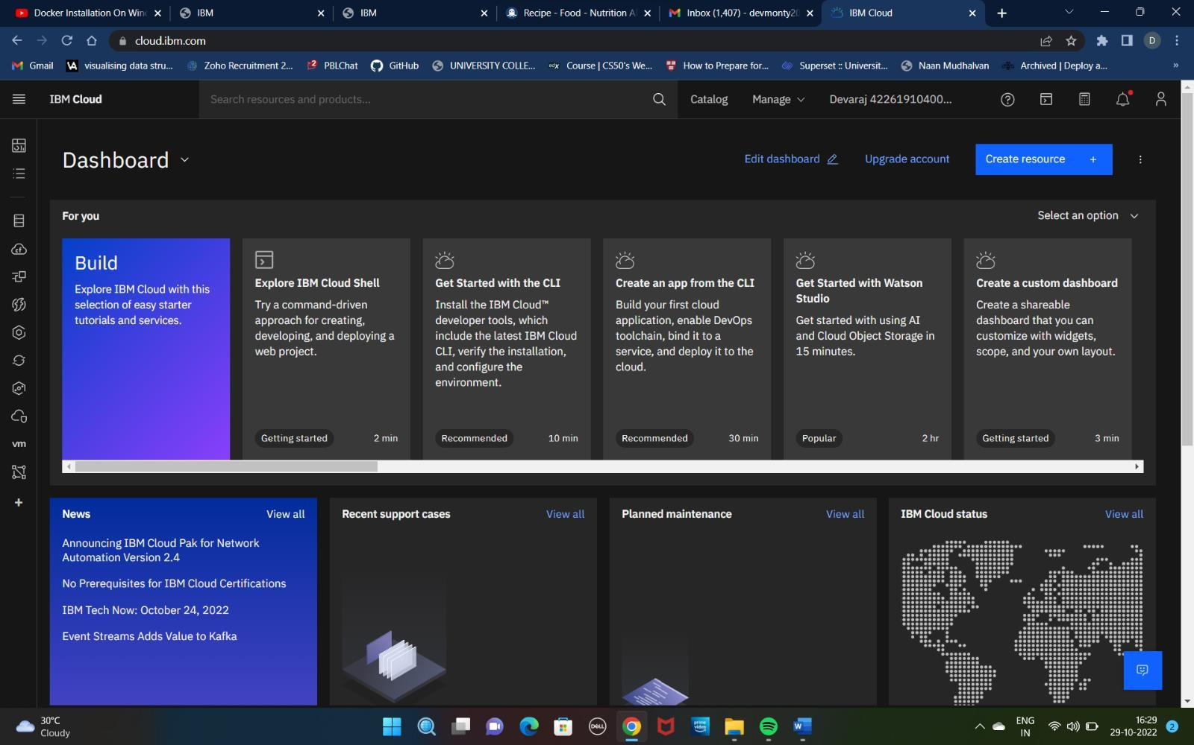

After clicking that tutorial, the instruction documentation page will open using those instructions to install IBM cloud CLI and also install some plugin-tools with the CLI for the work purpose while developing and deploying the Application.

Use the following Command to Install the IBM Cloud CLI:

iex (New-

ObjectNet.WebClient).DownloadString('https://clis.cloud.ibm.com/install/powershell') After Installed IBM cloud CLI the PowerShell screenshot shown below:

